Azure Durable Functions:
One of the primary benefits of Durable Functions is that they allow for the creation of stateful workflows in a serverless environment. These workflows can be paused and resumed without worrying about any loss of the state information, thanks to the Durable Task Framework that maintains checkpoints and handles restarts for you.

Azure Durable Functions are particularly useful in scenarios where you need to
1)execute a sequence of tasks in order,
2)handle errors, or roll back transactions,
3)manage state across a series of tasks.

Example:
Order Processing Systems: Durable Functions are ideal for e-commerce order processing, which can involve multiple steps such as inventory check, payment processing, and order fulfilment. Each step is dependent on the success of the previous one, and Durable Functions can handle the orchestration of these steps efficiently. In case of failure, you can define the necessary compensating actions, like issuing a refund if the order fulfilment fails after the payment has been processed.

Approval Workflow System: You can design a durable function to wait for human interaction for approval workflows. For example, in a document approval process, once a document is submitted, it can trigger a durable function to send an approval request to a supervisor. The function then waits until the supervisor either approves or rejects the document, after which it can take appropriate action.

https://topuzas.medium.com/azure-durable-functions-an-end-to-end-guide-with-c-549bd4dfb720

https://medium.com/@anubhav020909/day-22-vc -of-azure-functions-63960ea7f904

Core Concept Questions
- What is Azure Durable Functions and how do they differ from regular Azure Functions?
Azure Durable Functions are an extension of Azure Functions that allow stateful workflows and long-running processes. Unlike regular Azure Functions, which are stateless, Durable Functions maintain state, support orchestration, and can resume execution after delays or system restarts

.
- Explain the concept of serverless computing in Azure Functions.
Serverless computing allows developers to write and deploy code without managing infrastructure. Azure Functions automatically scale based on demand, making them cost-efficient and event-driven

.
- What are the key components of Azure Durable Functions?
  - Orchestrator Functions: Coordinate workflows and maintain deterministic execution.
  - Activity Functions: Execute individual tasks; results are stored for retries.
  - Client Function: Initiates an instance of the orchestration.

Patterns and Use Cases
- What are common patterns in Durable Functions?
  - Function chaining (sequential execution)
  - Fan-out/fan-in (parallel execution and aggregation)
  - Async HTTP APIs (monitoring long-running operations)
  - Monitor pattern (periodic condition checks)
  - Human interaction (pausing workflows for approvals/Rejections)

.
- Give examples of real-world use cases of Durable Functions.
  - Processing orders or payment workflows
  - Data aggregation across multiple services
  - Email or notification pipelines
  - IoT device state management using entities
  - Approval workflows requiring human interactions

6.Describe triggers and bindings in Durable Functions.
- Triggers: HTTP, Timer, Queue, and Event Grid triggers initiate workflows.
- Input bindings: OrchestrationTrigger ,ActivityTrigger, EntityTrigger.
- Output bindings: OrchestrationClient, SignalEntity, EntityState

Azure Functions are stateless and ideal for short-lived tasks, while Durable Functions extend Azure Functions to support long-running, stateful workflows.

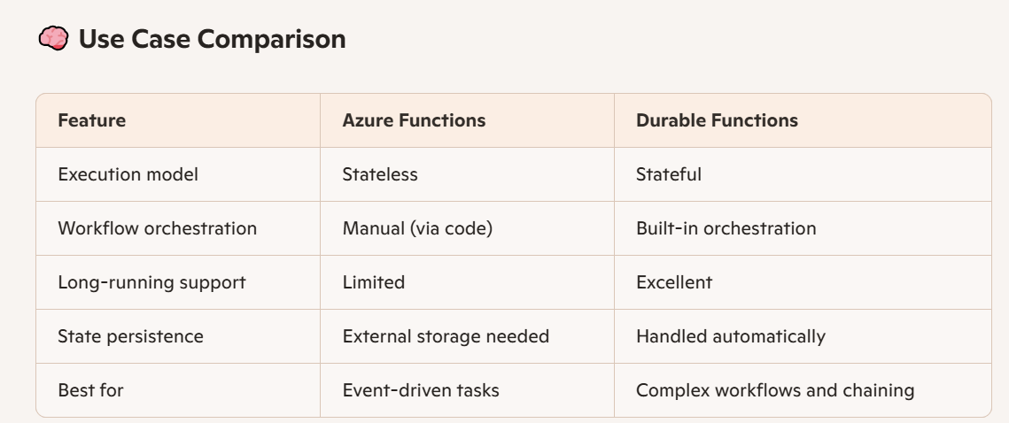

1)To end a Durable Function in Azure,
Ans:
you can either let it complete naturally, cancel it programmatically, or terminate it manually using the Durable Functions HTTP API.

You can cancel orchestrations using a Cancellation Token passed to the orchestrator or activity functions.

2)To handle exceptions in Azure Functions,
Ans:
Use try-catch blocks within your function code, implement retry policies for supported triggers, and optionally use middleware or logging frameworks for centralized error tracking.

The default timeout in Azure Functions varies depending on the hosting plan utilized:
- Consumption Plan: The default timeout is 5 minutes. This can be extended to a maximum of 10 minutes by configuring the functionTimeout property in the host.json file.
- Flex Consumption Plan, Premium Plan, and Dedicated Plan (App Service Plan): The default timeout is 30 minutes. The maximum timeout for these plans is unbounded (unlimited), allowing for longer-running operations.
- Container Apps: The default timeout is 30 minutes, with an unbounded maximum.

Benefits of Using Durable Functions
- Scalability: Automatically scales with demand.
- Resilience: Built-in retry and error handling.
- Maintainability: Clear separation of orchestration and activities.
- Cost Efficiency: Pay only for execution time.

  - [DurableClient] IDurableOrchestrationClient starter
StartNewAsync method
  - [OrchestrationTrigger] IDurableOrchestrationContext context

CallActivityAsync

  - [ActivityTrigger]

- Activity Functions:
  - ValidateOrderActivity: Validates the order details.
  - SendPaymentRequestActivity: Sends payment request (e.g., via SMS).
  - ProcessPaymentActivity: Processes the payment.
  - ShipOrderActivity: Manages inventory and shipping.

Azure Blob Storage:

https://medium.com/@jaydeepvpatil225/upload-file-into-azure-blob-storage-and-trigger-blob-storage-using-azure-function-4052e784f864

